Course General Notes

Contents

Week 1 1

# Week 1

Easy way to do Binary to Hex:

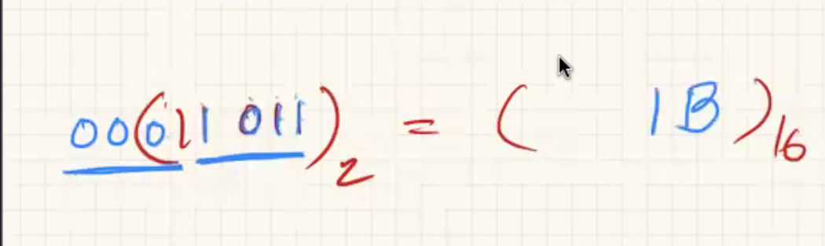

Calculating 2s complement

* Remember positive numbers start with 0, negative numbers start with 1.
* To get to one or the other, take the inverse of the number and add 1.

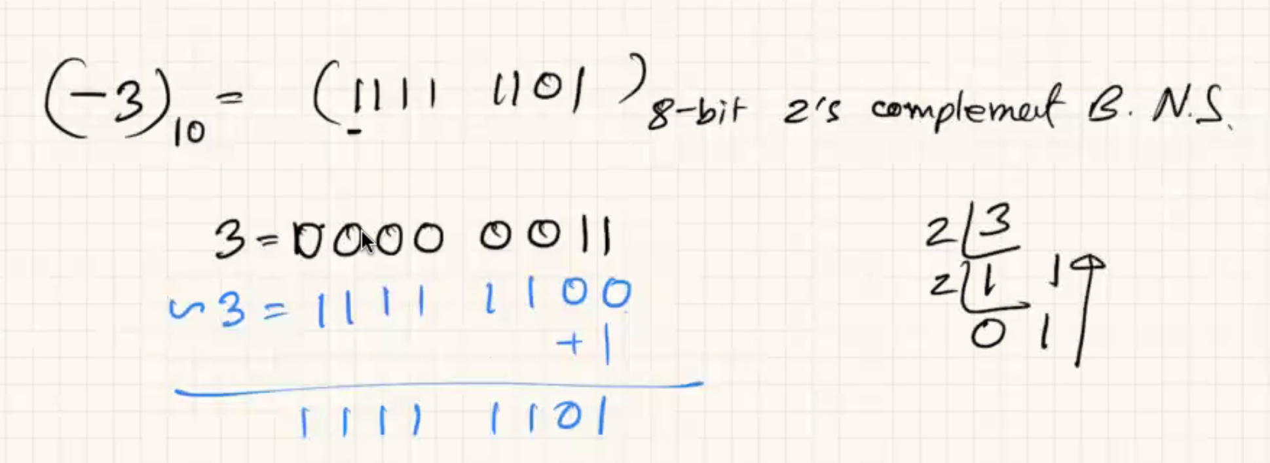

Converting Back:



